Task: Research online for 10 more linux commands aside the ones already mentioned in this module. Submit using your altschool-cloud-exercises project, explaining what each command is used for with examples of how to use each and example screenshots of using each of them.

Instruction: Submit your work in a folder for this exercise in your altschool-cloud-exercises project. You will need to learn how to embed images in markdown files.

1. Exit: this logout you out from the root user mode or any mode to default or where you intended to be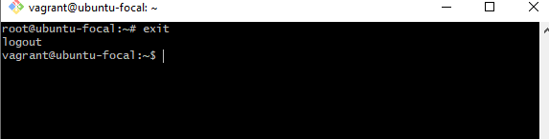
2. Sudo mkdir /usr/smt: The place to keep group folder is in the /usr folder

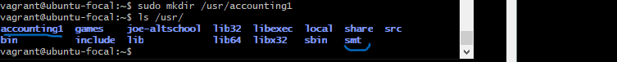

1. Chgrp: To change a file directory we have got to run this command chgrp for instance we have created a folder or file call ‘accounting’ and when we do ls -l /usr. We could see that the user that own the user directory is the ‘root’ and also the security group is also ‘root’

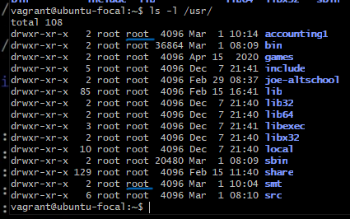

The underline user in blue is the group user will be change. If you want the accounting1 users to have access to the /usr folder you run this cmd below. Sudo chgrp

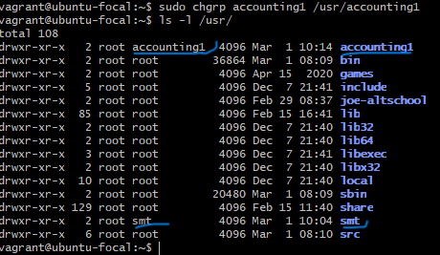

1. chmod Command

The chmod command lets you change the [mode of a file](https://wiki.archlinux.org/title/File_permissions_and_attributes) (permissions) quickly. It has a lot of options available with it.

The basic permissions a file can have are:

r (read)

w (write)

x (execute)

One of the most common use cases for chmod is to make a file executable by the user. To do this, type chmod and the flag +x, followed by the file you want to modify permissions on:

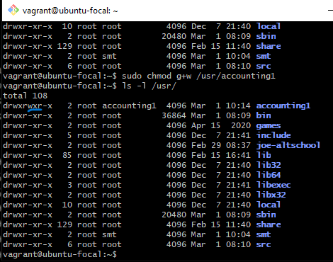

We can now see that the group permission that was xr (execute and read) has now the w (write) permission on it.

1. Apt: This command helps in installing application as seem below.

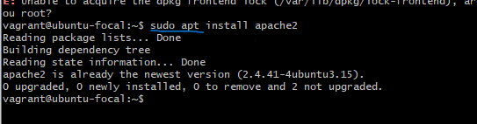

1. Sudo:

This command stands for “superuser do,” and it lets you act as a superuser or root user while you’re running a specific command. It’s how Linux protects itself and prevents users from accidentally modifying the machine’s filesystem or installing inappropriate packages.

Sudo is commonly used to install software or to edit files outside the user’s home directory:



1. Purge: This command helps in uninstalling installed application on the linux system as seem below.

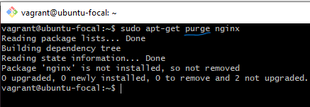

1. Htop: is an interactive process viewer that lets you manage your machine’s resources directlfrom the terminal.

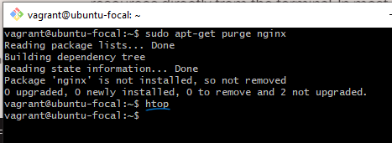

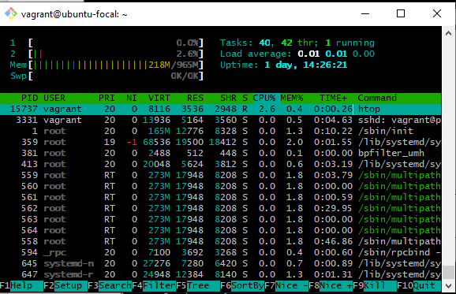

1. echo Command

The echo command displays defined text in the terminal — it’s that simple:

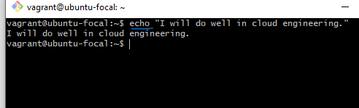

1. ps: With ps, you can take a look at the processes your current shell session is running. It prints useful information about the programs you’re running, like process ID, TTY (TeleTYpewriter), time, and command name.

